**TRIPLE DES ALGORITHM**

3DES cipher is quite popular block symmetric cipher, created based on [DES](http://www.crypto-it.net/eng/symmetric/des.html?tab=0) cipher. It was presented in 1998, and described as a standard ANS X9.52. It is also called Triple Data Encryption Algorithm (TDEA).

***Specification***

Block length = 64 bits

Key length = 56, 112, or 168 bits

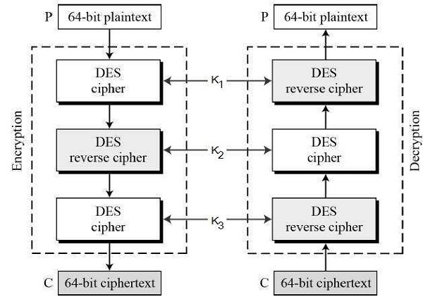3DES cipher was developed because DES encryption, invented in the early 1970s and protected by a 56-bit key, turned out to be too week and easy to break using modern computers of that time. The effective security which 3DES provides is 112 bits, when an attacker uses [meet-in-the-middle attacks](http://www.crypto-it.net/eng/attacks/meet-in-the-middle.html).

.

Fig.4. Triple -Data Encryption Standard Algorithm Procedure

# Algorithm to Encrypt an Image using Triple- DES Algorithm

1: Select an Image to Encrypt.

2: Declare a dynamic binary array of size = height of image * width of image * RGB_size.

The RGB_ size is 3.

3: Calculate Binary Value of each pixel of an Image.

4: Store all the RGB values of the pixel into the array.

5. Divide the binary array into blocks of size 64 bits.

6. This binary array is encrypted by using the DES Algorithm with K1 Key.

7. The encrypted array is decrypted using the DES Algorithm with K2 Key.

8. Again, the decrypted array is encrypted using DES Algorithm with K3 Key.

9. The final encrypted array is the cipher array.

10. Declare a dynamic binary array of size = height of image * width of image * RGB_size. Now arrange the cipher values into the image .

11. The image now formed is the encrypted image file

12. Exit.